**Business Problem Statement**

In recent years City hotels and Resort have seen High Cancellation rates, each hotel is dealing with lots of issues as a result including fewer revenues and less than ideal hotel room use. Consequently, lowering cancellation rates, primary goal in order to increase efficiency in generating revenueand for us to offer thorough business advice to address this problem.

The Analysis of Hotel Booking Cancellation as well as other factor that no bearing on their business and yearly revenue generation are main topic of this report.

**Objectives**

What are the major factor that affect hotel reservation Cancellation.

How can we make hotel reservation cancellation better.

How will hotel assisted in making pricing and promotional decision.

**Hypothesis**

More cancellation occur where prices are higher.

Mostly customers are coming through offline travel agents for hotel reservation.

When there is longer waiting list, customer tend to cancel more frequently.

**Challenges**

While doing EDA, we see that the data consist of lots of null values ,to handle this we drop such columns and rows that is not so necessary for analysis.

Also we face such Outliers like as we see overall statistics of this data, there are some columns like children, adult, Average daily revenue [adr] consist outliers so we remove them with some logics or filters.

Some columns which associate with the inappropriate datatype, we also that issue with assigned that columns with the appropriate datatype which helps us in analysis of this dataset.

**Analysis**

* As per Analysis by proving the hypothesis wrong we have come to this conclusion that the mostly customers is coming through the online travel agent.

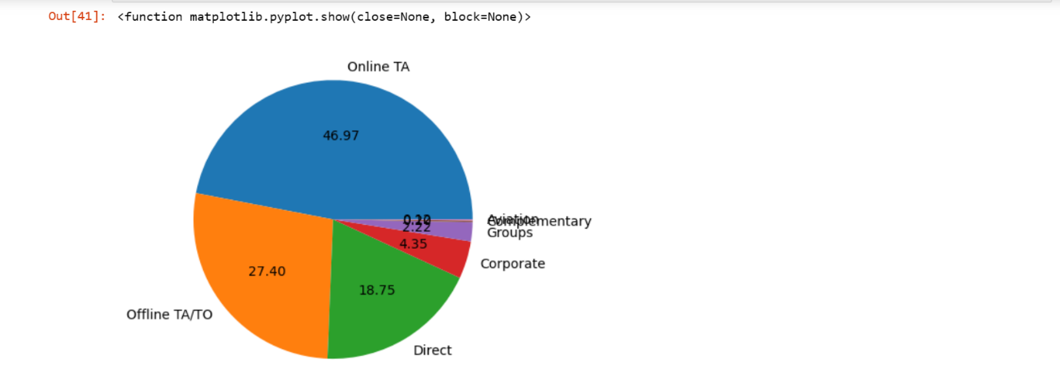

Fig: Customers Through Marketing Segment

* Portugal has high cancellation rate around 70.7% among all country

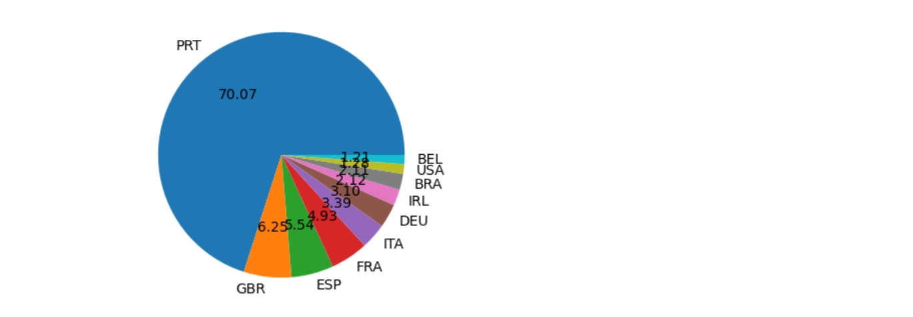

Fig: Cancellation Rate of all Country

* As per hypothesis we can say that high cancellation rate is proportional to the high adr ,as adr increase cancellation rate also increase.

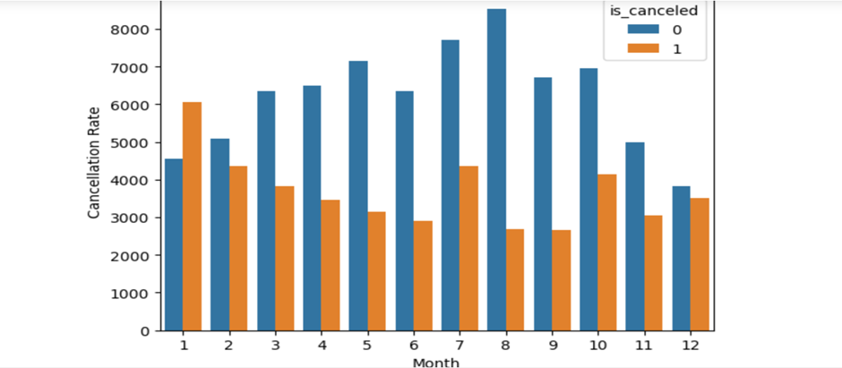

Fig: Cancellation Rate by Month

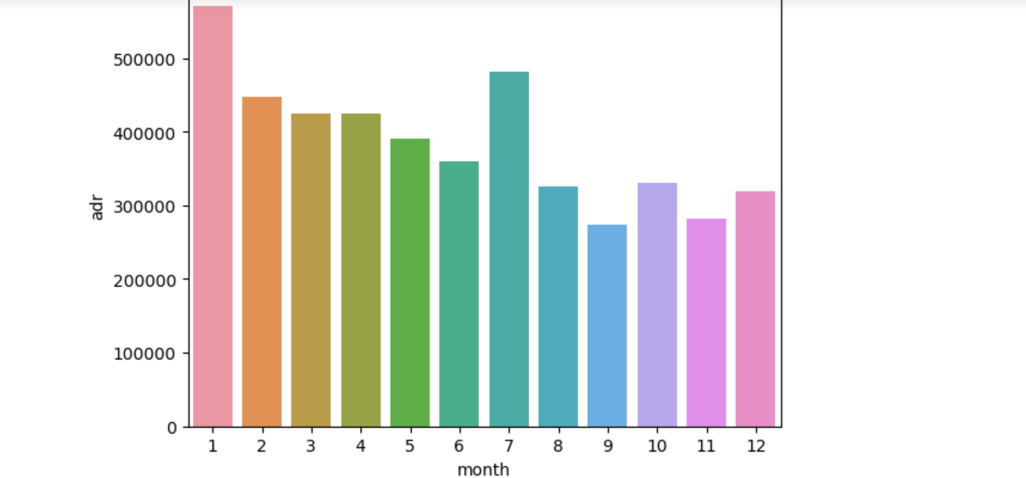

Fig: Cancellation Rate by ADR

* On compare both hotels ,City Hotel has high cancellation rate as compare to Resort Hotel.

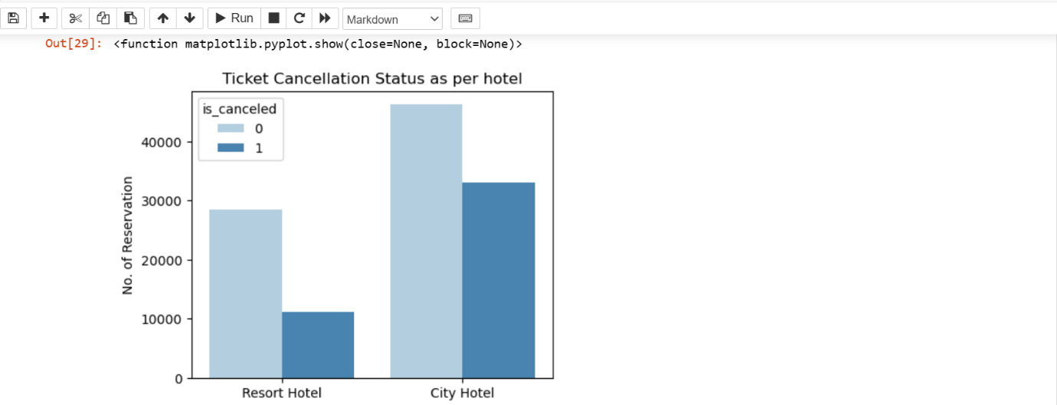

* As per Market Segment high reservation as well as high cancellation is done through online TA/TO

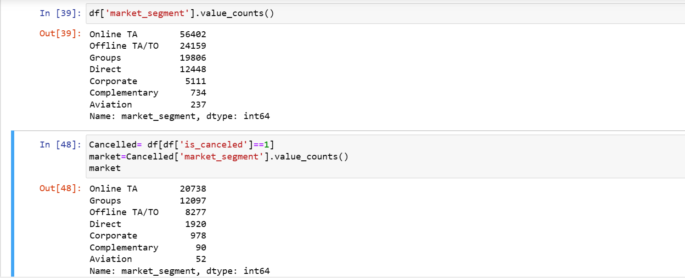

* As per Customer Type “Transient” has book hotels more without cancellation.
  + 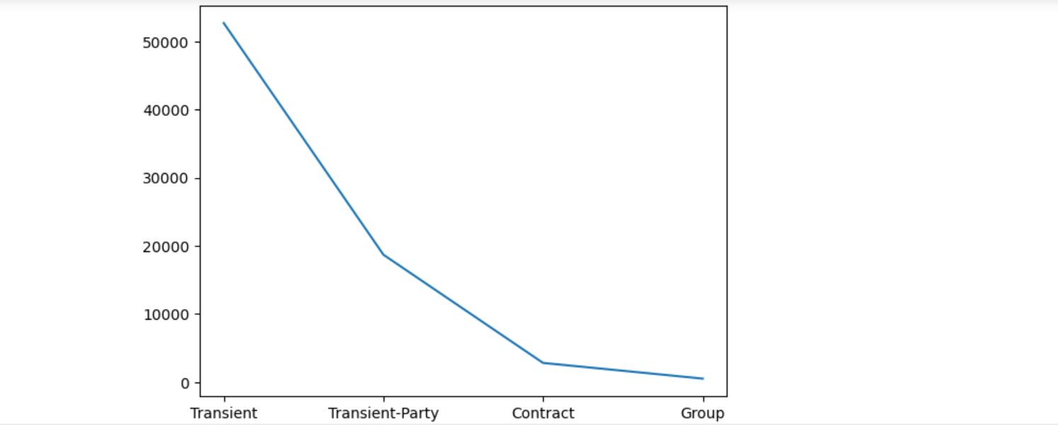
* This Line graph shows that on weekend days the adr of hotels rises as compare to normal weekdays.

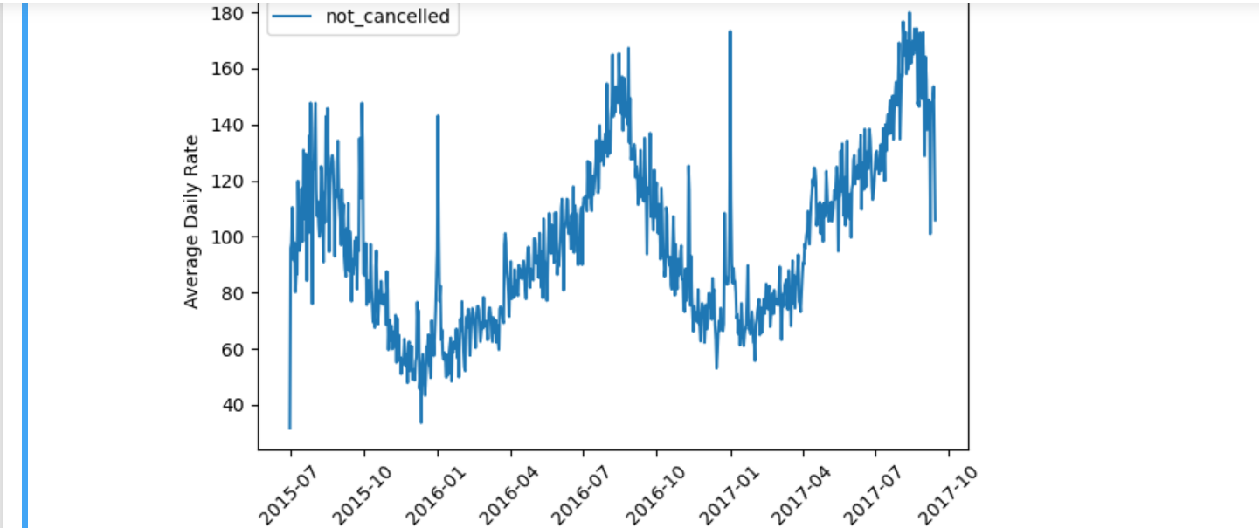

Fig: Average Daily Rate for Non-Cancellation Over Time